**Task 2-**

**Objective- Push a docker image into docker hub**

Step 1:- Create a file with extension .dockerfile

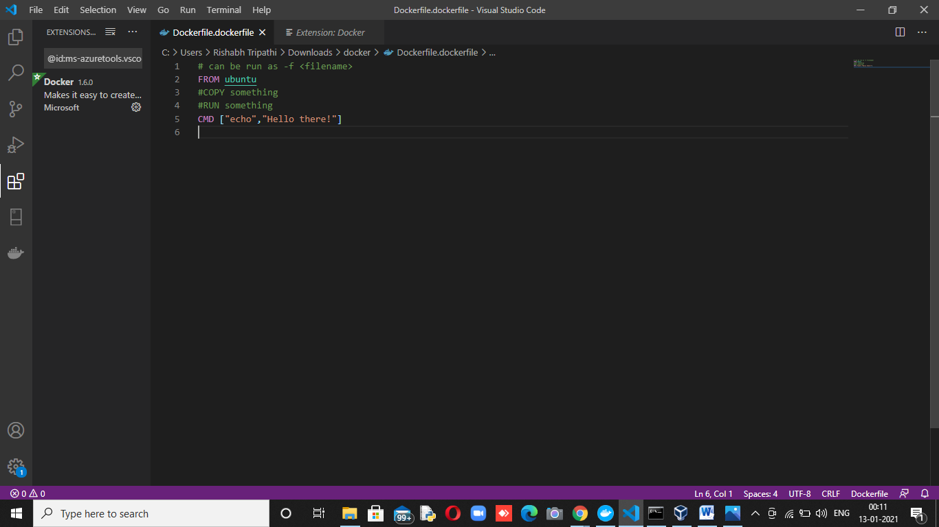

Step 2:- Build docker file with command

docker build -t myimage:latest -f Dockerfile.dockerfile .

image name -myimage

tag -latest

filename:- Dockerfile.dockerfile

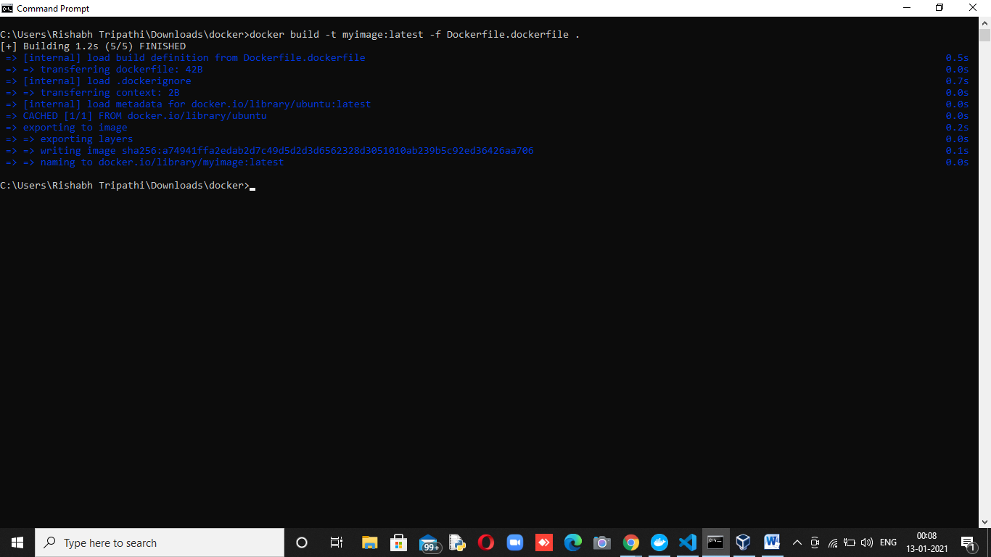

Step 3:- Tagging the same image to upload in dockerhub with command

docker tag myimage:latest 123rishabhtrip/my_image:latestcls

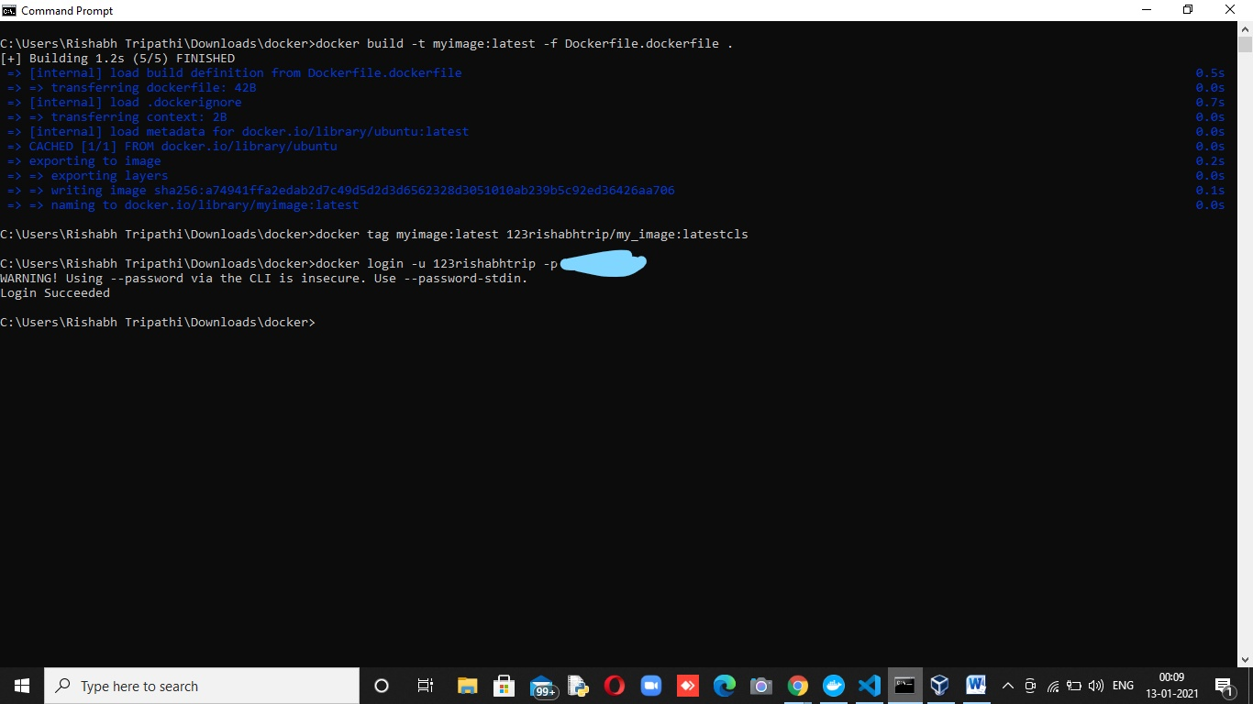

Step 4:- Login in the docker hub using command

docker login -u myusername -p mypassword



Step 5:- Push the image in docker hub using command

docker push 123rishabhtrip/my_image:latest

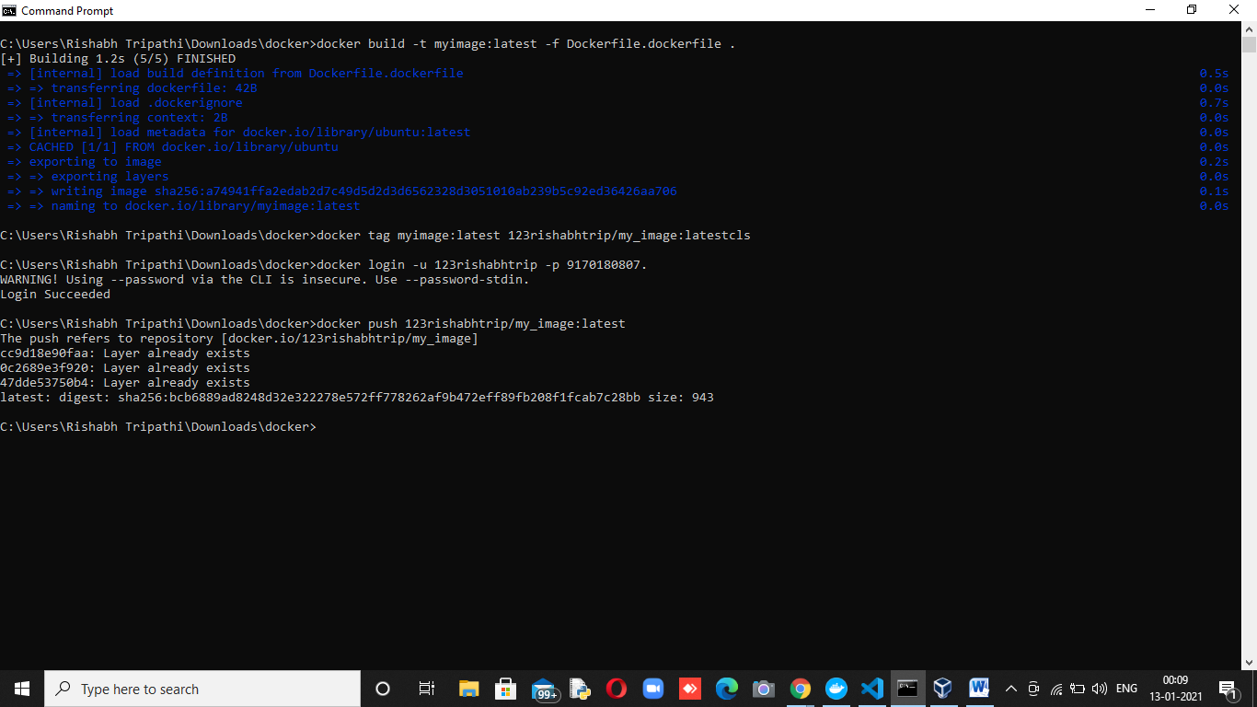

Step 6:- Checking the image is pushed in dockerhub or not

<https://hub.docker.com/r/123rishabhtrip/my_image>  
